PROJECT PROPOSAL

Project Title: AdmitPilot: A Multi-Agent Decision Support System for Graduate Admissions Planning

Project Sponsor: N/A

Project Members (Group 26): Tang Yutong, A0330149L
Chen Jinghao, A0329642Y
Zhang Yufei, A0328587L
Shi Junren, A0329467N

Overview:

Graduate admissions planning is increasingly challenging due to fragmented information sources, evolving requirements, and the need to coordinate multiple interdependent tasks over an extended preparation period. For applicants targeting universities in Hong Kong and Singapore, official admissions information, FAQs, deadlines, and informal offer cases are often distributed across heterogeneous channels, making reliable planning difficult.

To address this problem, we propose AdmitPilot, a multi-agent decision support system for graduate admissions planning. Rather than automating final applicant decisions, AdmitPilot is designed to provide structured and explainable support across the full planning workflow, including admissions information retrieval, profile-based school selection, timeline construction, and document preparation. The system is coordinated by PAO (Principal Application Orchestrator) and supported by four specialized sub-agents: AIE (Admissions Intelligence Engine), SAE (Strategic Admissions Evaluator), DTA (Dynamic Timeline Architect), and CDS (Core Document Specialist).

The project aims to transform fragmented admissions tasks into an integrated, interpretable, and practically actionable workflow for applicants.

Scope of Work:

1. System Scope

AdmitPilot focuses on graduate admissions planning for institutions in Hong Kong and Singapore. The system supports four core functions:
- Retrieval and organization of admissions information and historical knowledge
- Applicant-profile evaluation and school selection support
- Backward-planned application timeline generation
- Document support for CVs, personal statements, and interview preparation
As a concept proposal, this project emphasizes agent roles, collaboration logic, explainability, governance, and prototype feasibility, rather than full automation of application submission.

2. Agent Design

PAO – Principal Application Orchestrator
PAO serves as the central coordination layer. It is responsible for intent recognition, task decomposition, agent routing, context management, and final response aggregation. PAO ensures that all agents operate under a shared application context and that composite requests are handled coherently.

AIE – Admissions Intelligence Engine
AIE functions as the shared admissions knowledge layer of the system. It maintains:
- Official Memory: structured information from university websites, program pages, FAQs, deadlines, and historical requirement snapshots
- Case Memory: cleaned offer cases, timing patterns, and source credibility labels
AIE retrieves current-cycle admissions information, identifies whether official updates have been released, generates confidence-aware forecasts when current-cycle information is incomplete, and provides standardized admissions intelligence for downstream agents.

SAE – Strategic Admissions Evaluator
SAE is responsible for applicant-program matching and school selection analysis. Based on user background and AIE’s intelligence, SAE produces:
- Reach / Match / Safety grouping
- strength–weakness summary
- gap analysis
- risk-aware recommendation order
To remain feasible and implementable, SAE adopts a practical hybrid evaluation framework based on structured rules, semantic matching, and risk-aware ranking.

DTA – Dynamic Timeline Architect
DTA translates strategic recommendations into a time-based execution plan. Using school priorities from SAE, admissions timelines from AIE, and user constraints managed by PAO, DTA generates:
- dynamic timeline or execution board
- week-level task structure
- milestone and risk markers
- document preparation instructions for CDS
Its purpose is to convert long-term application goals into a manageable and adaptive plan.

CDS – Core Document Specialist
CDS provides document-oriented support by integrating user experiences with the outputs of SAE and DTA. It generates:
- customized PS / SoP drafts
- dynamically aligned CV content
- interview talking points
- narrative completion feedback
CDS is designed as a human-centered refinement module. It supports authenticity, personalization, and cross-document consistency, while preserving human review and final user approval.

3. Agent Orchestration

A typical workflow proceeds as follows:
- The user submits a natural-language request
- PAO identifies intent and decomposes the task
- AIE supplies admissions facts, historical knowledge, and case-based evidence
- SAE evaluates applicant fit and produces a school selection strategy
- DTA converts the strategy into a backward-planned timeline
- CDS generates document support based on prior outputs
- PAO integrates all results into a coherent recommendation package
This design demonstrates both agent specialization and centralized orchestration.

4. Assurance, Trust, Fairness, and Accountability

AdmitPilot is designed as a decision support system, not a deterministic admissions predictor. To ensure trustworthy use:
- Trust: Official sources are prioritized over informal community data.
- Fairness: Recommendations are not based solely on rankings or prestige, but on applicant fit, feasibility, and user goals.
- Accountability: Final decisions remain with the user; the system provides support rather than authoritative judgment.
- Explainability: Key outputs, such as school grouping, priority ordering, and highlighted document content, should be accompanied by concise reasons.

5. Ethical Issues and Governance

The system will not support fabrication, exaggeration, or misleading representation of applicant experiences. It is intended to help users articulate authentic materials more effectively, not to bypass institutional review processes. Verified facts, inferred case patterns, and forecasted suggestions must be clearly distinguished.
To support governance, the prototype will record prompt templates, retrieval sources, output versions, and human revision steps, providing a lightweight basis for traceability and quality control.

6. Security Measures

Although the current project is a concept proposal, the prototype should still follow basic security principles:
- collect only minimum necessary personal data
- restrict access to sensitive applicant information
- separate shared knowledge memory from private user data
- maintain logs for external data retrieval and error handling
These measures provide a foundation for safe and responsible prototype development.

7. MLOps / LLMOps Considerations

Given the use of LLM-based reasoning and retrieval, the prototype should include lightweight engineering controls such as:
- prompt template versioning
- retrieval source logging and caching
- module-level input/output interface definitions
- sample-based output review and failure case analysis
These practices are sufficient for a course-level concept proposal and prototype demonstration.

Effort Estimates:

The project requires a total of 46 man-days, organized into four development phases to align with the project timeline and Gantt chart.

Phase 1: Design Phase (Week 1–3) — 30 man-days

This phase focuses on system definition and agent-level design, with parallel development across modules.

WP1 Requirements and Scope Definition — 4 man-days (ALL)

Define user scenarios, system boundaries, and workflow
Establish agent roles and overall architecture
Finalize system input/output schema

WP2 & WP3 Core Architecture (PAO + AIE) — 14 man-days (TANG)

Design orchestration logic (PAO): task decomposition, routing, context management
Construct knowledge layer (AIE): official memory and case memory
Ensure consistency across all agent interactions

WP4 SAE Design — 8 man-days (CHEN)

Applicant profiling and normalization
Matching rules and ranking strategy
Risk-aware recommendation (Reach / Match / Safety)

WP5 DTA Design — 8 man-days (ZHANG)

Backward timeline planning
Task dependency modeling
Scheduling and dynamic adjustment

WP6 CDS Design — 8 man-days (SHI)

Document template design (PS, SoP, CV)
Narrative consistency mechanisms
Human-in-the-loop refinement

Phase 2: Development Phase (Week 3–5) — 10 man-days

WP7 Implementation — 10 man-days (ALL)

Implement all agent modules based on design specifications
Ensure module-level functionality and correctness
Conduct initial validation of agent outputs

Phase 3: Integration Phase (Week 5–6) — 6 man-days

WP8 Integration and Testing — 6 man-days (ALL)

Integrate all agent modules through PAO
Align input/output interfaces across agents
Debug coordination issues and validate system flow

Phase 4: Delivery Phase (Week 7–8) — 4 man-days

WP9 Demo and Refinement — 4 man-days (ALL)

Refine outputs and improve usability
Prepare demonstration scenarios and examples
Finalize system presentation and documentation

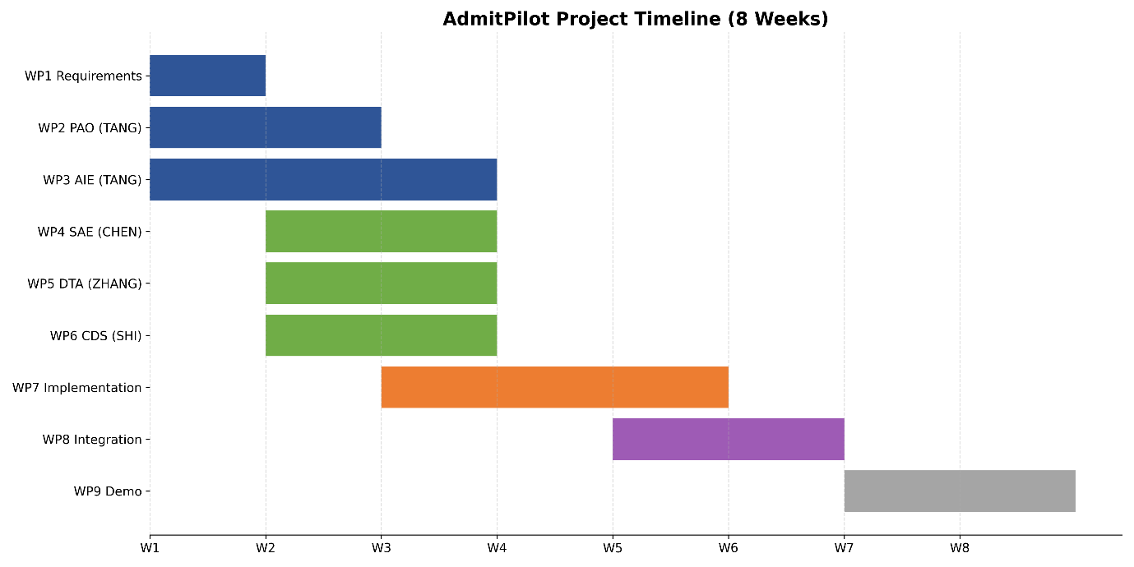

Summary

The effort allocation follows a phased and parallel development strategy, where:
Early stages emphasize agent design and architectural alignment
Mid-stage focuses on implementation and functional validation
Later stages prioritize integration stability and system delivery

This structure ensures that risks related to multi-agent coordination are addressed early and managed progressively throughout the project lifecycle.

